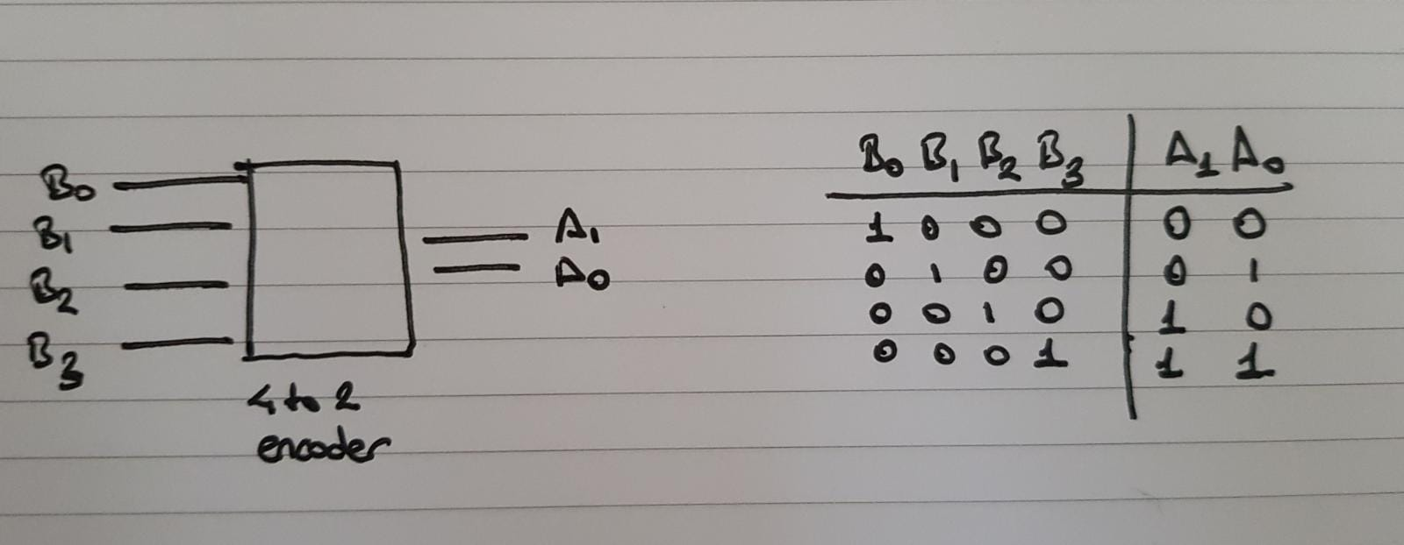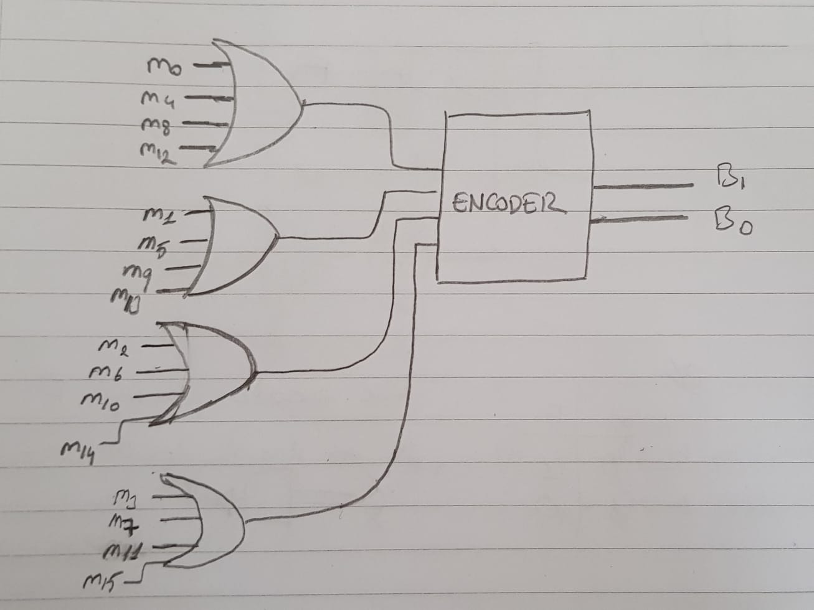**ELEC 204 Digital Design Preliminary Lab Report**

Preliminary Lab 2

Name: Mehmet Enes Erciyes

Date: 10/24/2019

*Please delete the highlighted lines and write your own parts for the report.

**Reminder: Your lab grade is a weighted average of your performance before, during and after the lab: **Total lab grade = Preliminary work* (30%) + Lab interview and demo* (40%) + Lab report (30%)**

**\*\*\*Please make sure the preliminary report does not exceed 2 A4 pages.**

For the preliminary work, please provide here:

* QUESTION 4.1

Encoder circuit for the question

Truth Table for 4-to-2 Encoder

Minterms in the given encoder circuit are as follows:

m0 = (A3)’(A2)’(A1)’(A0)’

m1 = (A3)’(A2)’(A1)’(A0)

..

..

..

* QUESTION 4.2

In question 2, there are 4 outputs. But, A3 and A0 are equivalent as well as A2 and A1. Therefore we can draw two decoder circuits implementing this function. In this implementation, we used 1-to-2 decoders with the following truth table:

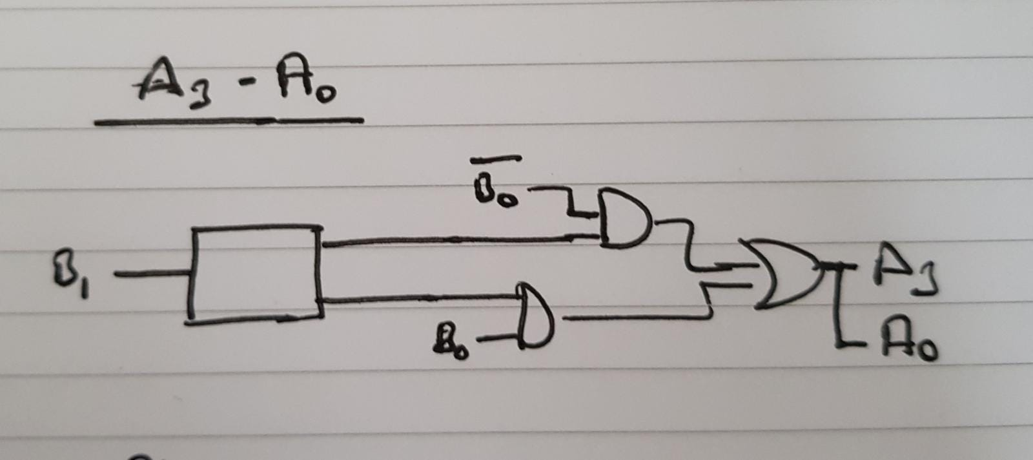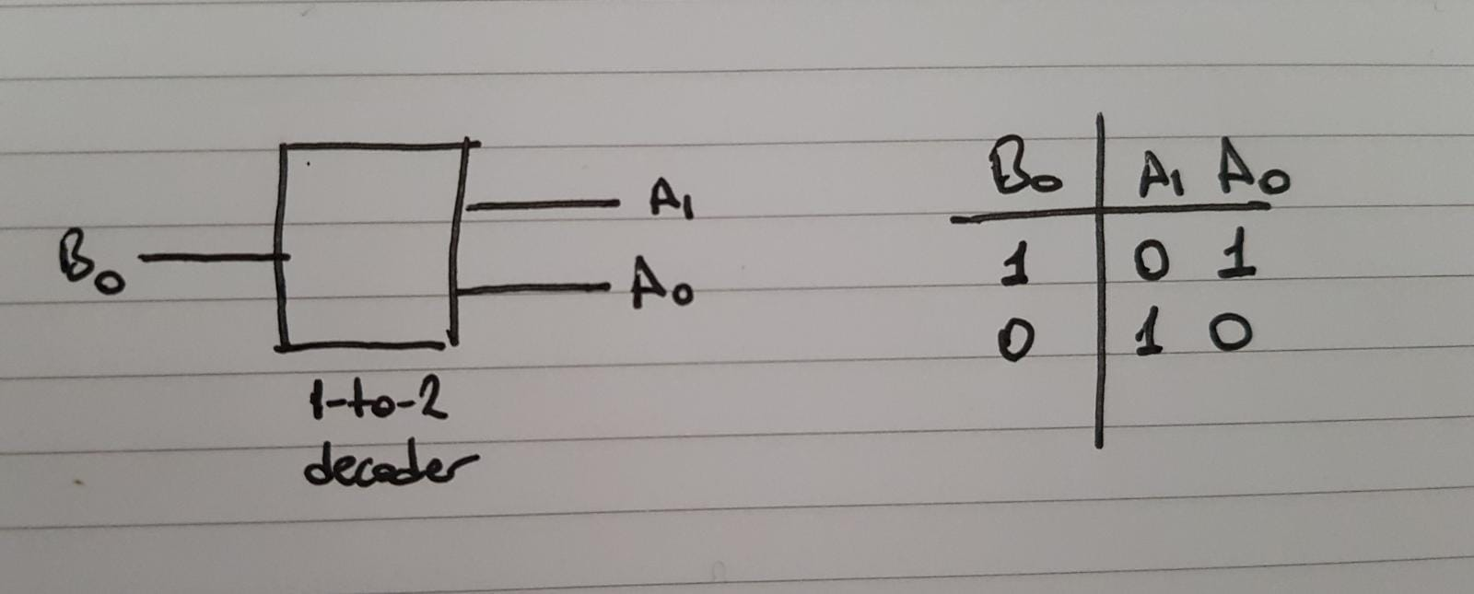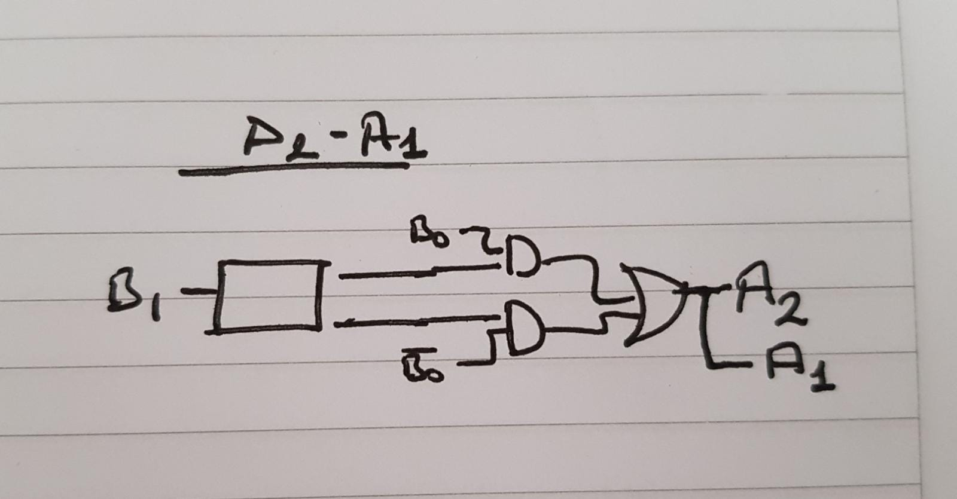

DECODER CIRCUITS FOR OUTPUTS

* QUESTION 4.3

Truth Table for 4-to-1 Multiplexer

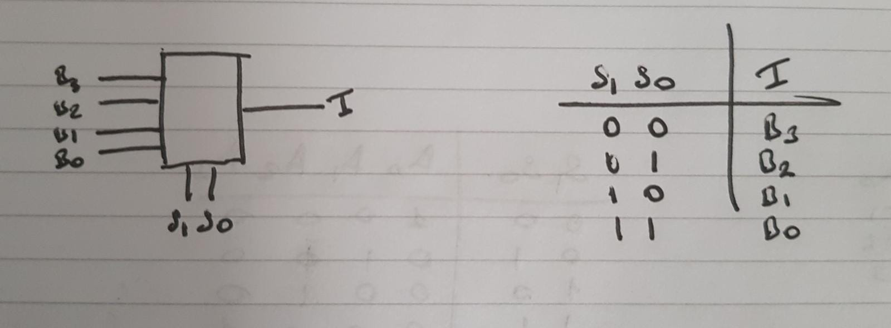

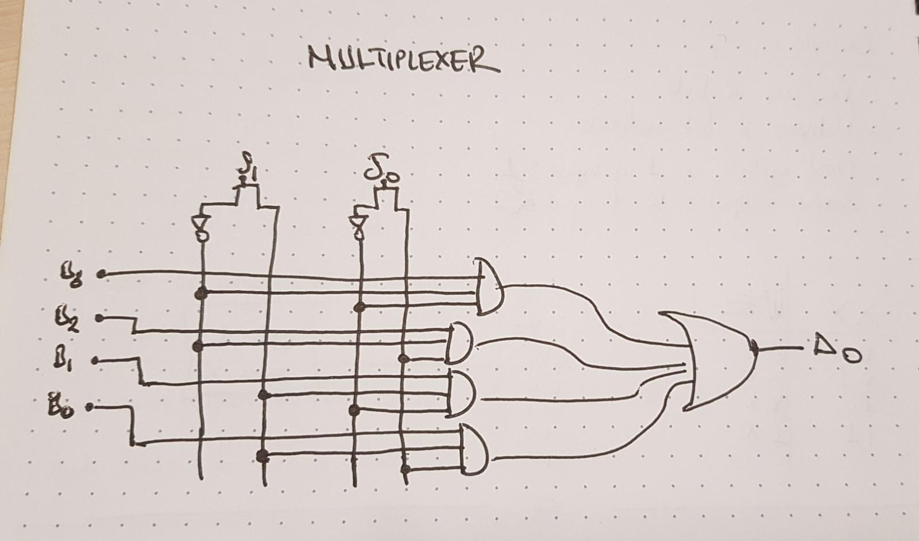

Multiplexer Design

* 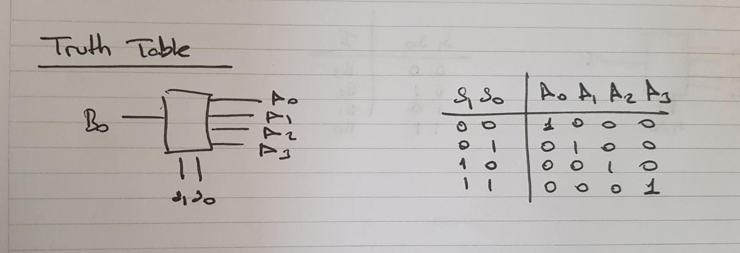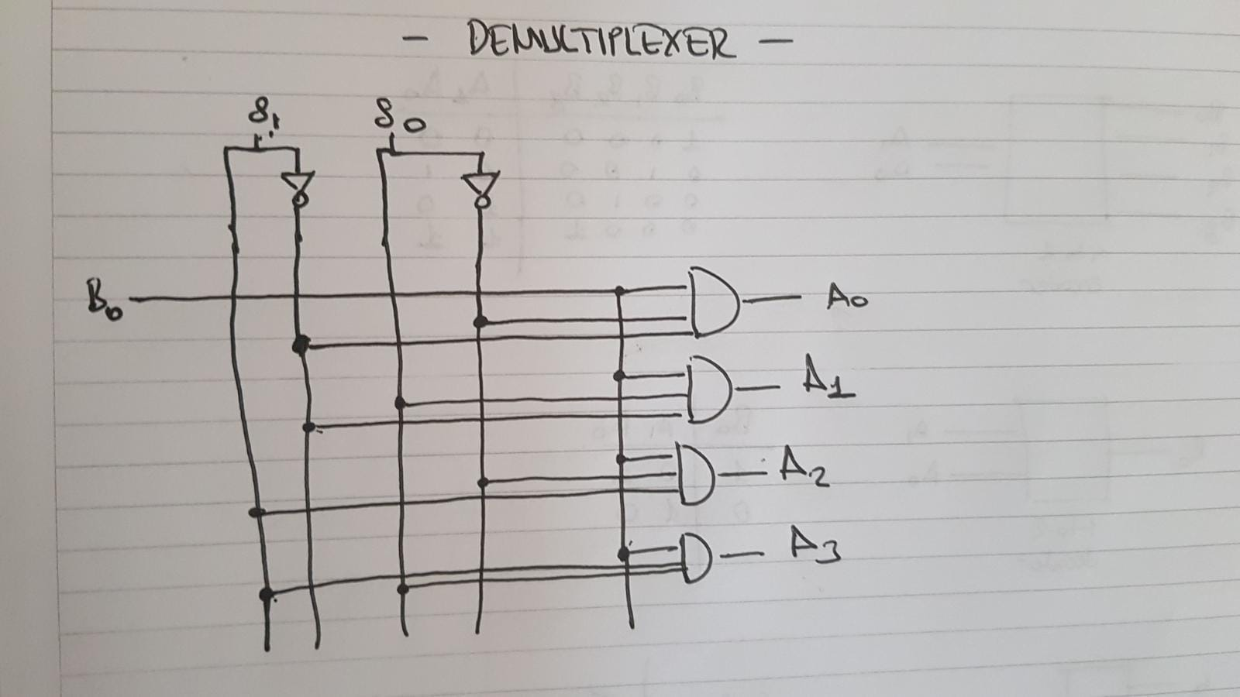QUESTION 4.4

Truth Table for De-multiplexer

De-multiplexer Design